

**Visual Basic.NET**

**Technology Park Malaysia**

**AAPP008-4-2-VBN**

**Documentation on Cheerful Café System**

**Individual Assignment**

**Name: SIA CHEE ZHEN (TP056392)**

**Lecturer: DR. TAN CHYE CHEAH**

**Module Code: AAPP008-4-2-VBN (Visual Basic.Net)**

**Intake Code: UCDF1905ICT(SE)**

**Hand-out-Date: 13th April 2020**

**Hand-in-Date: 1st June 2020**

**CHEERFUL CAFÉ SYSTEM**



***Acknowledgement***

Before moving on, I feel thankful and indebted to The **All-Powerful God** for allowing the completion of my assignment without any hiccups.

In addition, I will like to sincerely thank **Datuk Dr. Parmjit Singh**, ***Chairman of Asia Pacific University***, for providing me with all the necessary facilities and the suitable environment that contributed to me able to complete my assignment with high efficiency and effectiveness.

Furthermore, I will also like to put forward, my profound appreciation to **Prof. Ron Edwards**, ***Vice Chancellor of Asia Pacific University***, for the presentation that he has given to me during my first Orientation Day in Auditorium One that has continued to be a catalyst to strive for academic distinctions in spite of all the difficulties that I have encountered during the strenuous journey.

Besides that, I will like to thank **Dr. Tan Chye Cheah**, my ***Visual Basic.Net (VBN) Lecturer, Faculty of Computing, Engineering & Technology, School of Computing and Applications Development***. I am highly indebted and thankful to him as I am able to achieve the best possible result and in accomplishing this difficult but eye-opening assignment because of his profound expertise, devoted and invaluable counsel and encouragement that were provided.

Moreover, I will like to take this chance to truly thank all my **family and companions** for their invaluable and unmeasurable encouragement, counsel and believing in me that I would be able to attained the completion of this assignment.

Lastly, I will love to put forward my indebtedness and gratefulness to **each and every one** who had directly or indirectly lent their assistance to me in ensuring a smooth sailing for the accomplishment of this assignment, thank you and god bless everyone!

**Table of Contents**

**1.0 Introduction** 5

**2.0 Storyboard** 6

**2.1 Login Form** 6

**2.2 Main Menu Form** 7

**2.3 Menu & Payment Form** 8

**2.4 Staff Registration Form** 10

**2.5 Customer Registration Form** 11

**2.6 Payment History Form** 12

**3.0 User Manual** 13

**3.1 Login Function** 13

**3.2 Main Menu Directing to other forms** 15

**3.3 Playing Music** 16

**3.4 Enabling “Menu” Option** 16

**3.5 Ordering and Transactions** 20

**3.6 Extra Relevant Functions (Menu)** 24

**3.7 Registration (Staff)** 25

**3.8 Search and Update Function (Staff)** 27

**3.9 Extra Relevant Functions (Staff)** 28

**3.10 Registration (Customer)** 29

**3.11 Search and Update Function (Customer)** 31

**3.12 Extra Relevant Functions (Customer)** 32

**3.6 Transaction History** 34

**4.0 Testing** 35

**5.0 Critical Assessment** 39

**5.1 Strengths** 39

**5.2 Weaknesses** 40

**5.3 Recommendation for Future Updates** 42

**6.0 References** 43

**7.0 Appendix:** 46

**7.1 Gantt Chart:** 46

# **1.0 Introduction**

**Cheerful** **Café** **System** can be described as a Point of Sales (POS) System and a Café Management System which is simple and fun to be used by Cafeteria owners and their employees to manage customers’ orders and transactions with highest accuracy and efficiency.

This system is built with the **objective** to tackle problems such as ***inaccuracy*** ***and*** ***inefficiency*** in terms of taking orders manually without using the help of technology. For example, there are still café nowadays which does not utilize technology to take customers’ orders whereas, they take the order down manually using paper and pencils, and calculating the change and total of transaction using mental calculation which has a high inaccuracy and inefficiency due to the high probability of human errors occurring. Besides that, this system is also built to be ***simple and fun*** for employee to use and work with. For example, there will be a music button that could be pressed by employees to play music and listening to it while working, so that they will always be energized and not bored. In terms of ***simplicity***, this system is not very complicated as even users who have not touched a computer before will be able to master it within days or a week.

The **main** **functions** that will be included into this system is ***calculation***, ***registration***, ***authorization***, ***ordering*** and ***transaction***. In terms of **calculation**, function to calculate taxes, getting the total, and change to be given back to customer will be added into the system under the menu & payment page. **Registration** on the other hand will be to register new customers’ details before they are allow to make any orderings and transactions under the customer registration page, whereas this function is also to allow the registration of new employees’ credentials and allowing them to access this system under the staff registration page. Besides that, **authorization** is to validate that users of this system such as the staffs, when input the correct usernames and passwords are allowed to access the system and to carry out any of the functions in the system. Furthermore, **ordering** will be used to manage customers’ orders so that staff do not have to memorize customers’ orders or need to jot down customers’ orders on papers manually, when staffs can just press on the items that customers want to order and the items will automatically be added into a cart and by the end of the transaction the items ordered will be saved to the database. Last but not least, in terms of **transaction**, payment made by customers such as the total price of items ordered and taxes that should be paid, and changes that should be given back to customers will be recorded in the database and can be reviewed in the history page later on.

# **2.0 Storyboard**

## **2.1 Login Form**

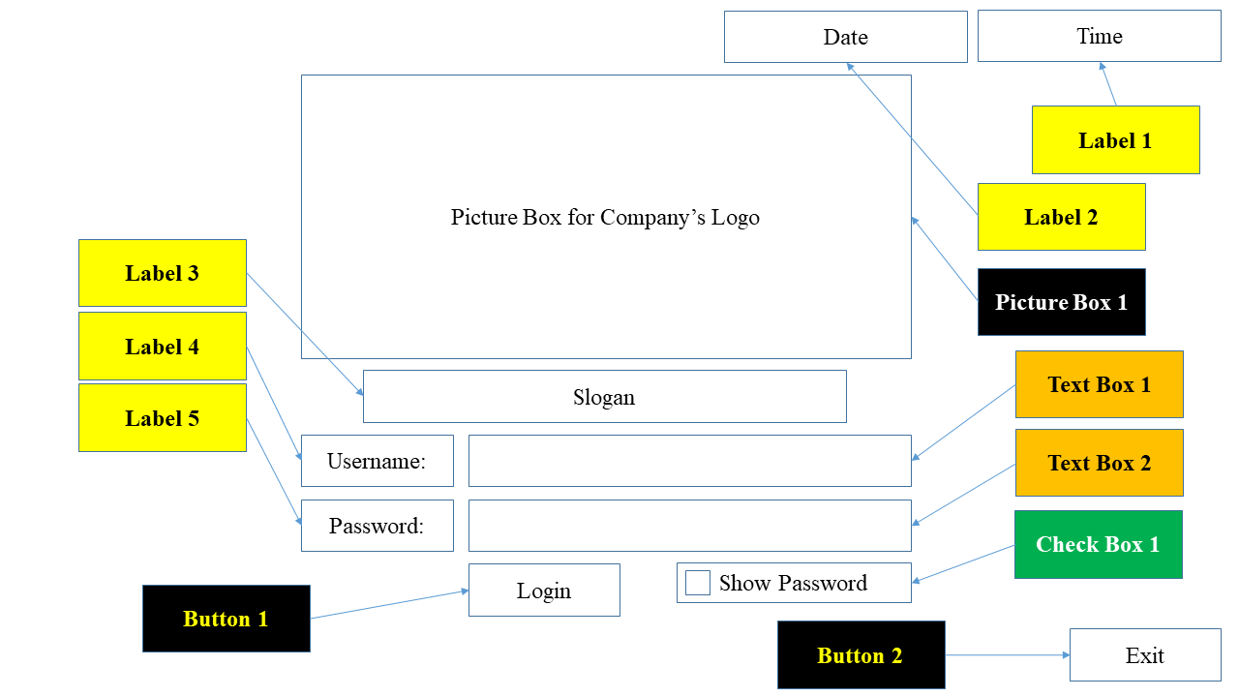

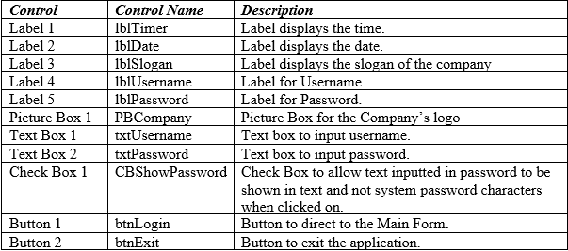

## **2.2 Main Menu Form**

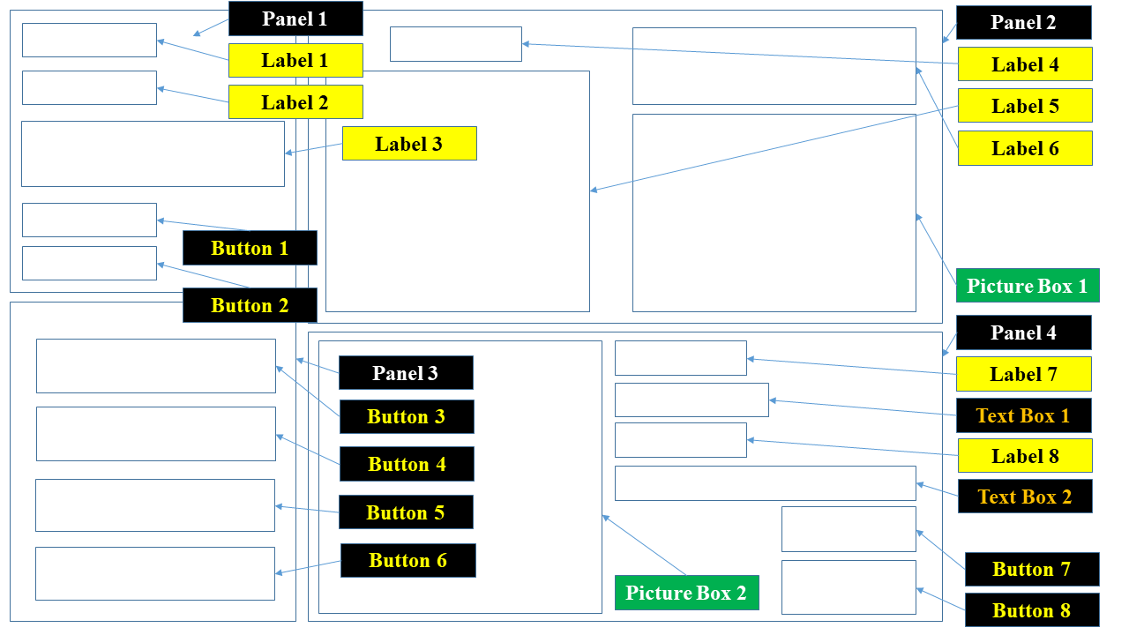

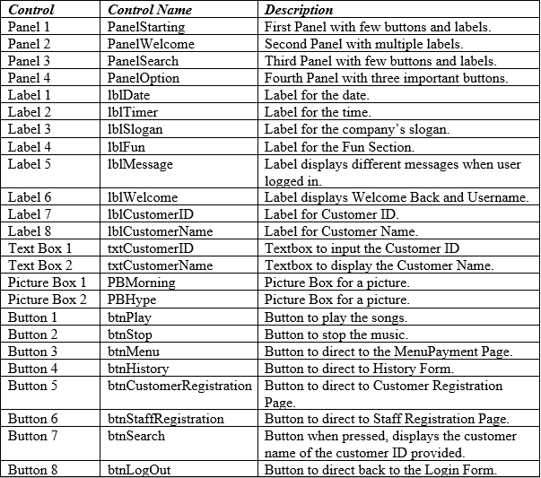

## **2.3 Menu & Payment Form**

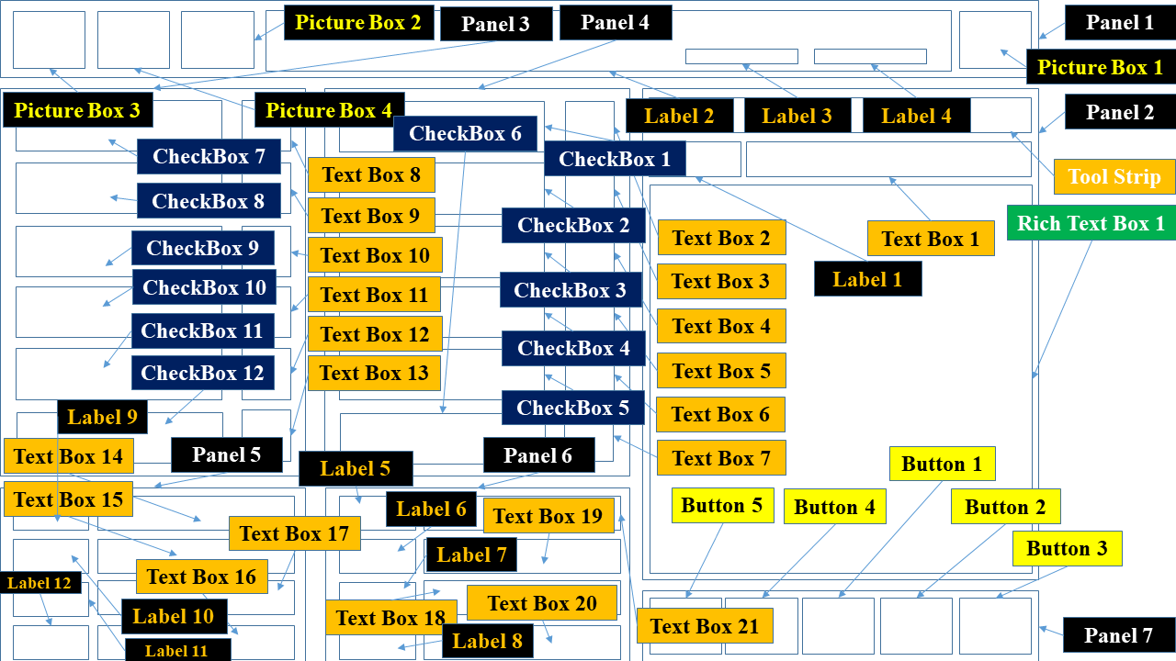

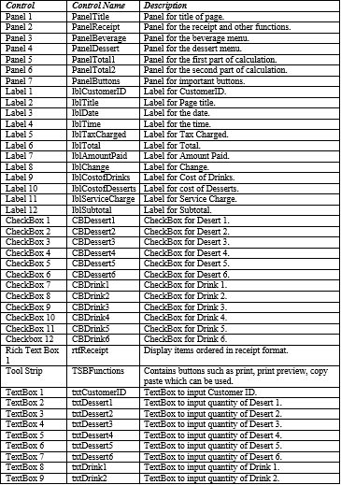

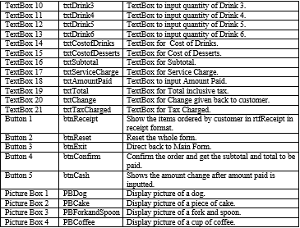

## **2.4 Staff Registration Form**

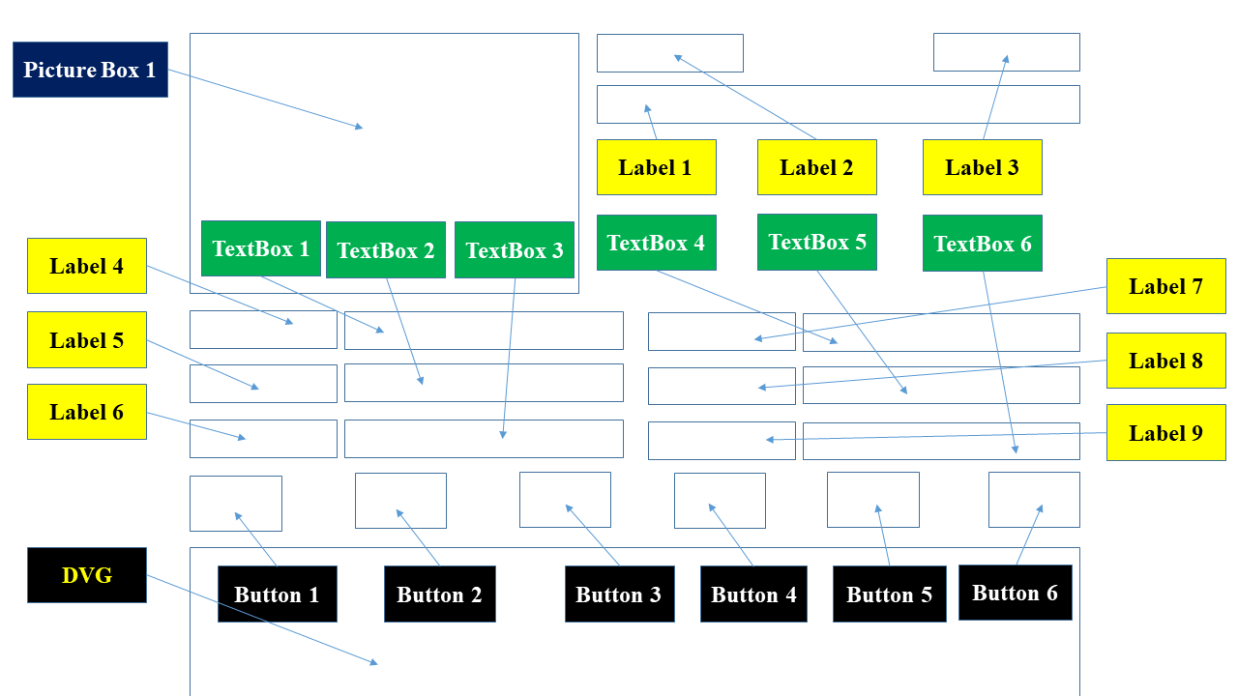

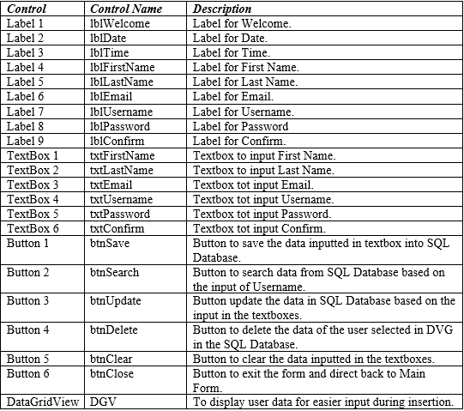

## **2.5 Customer Registration Form**

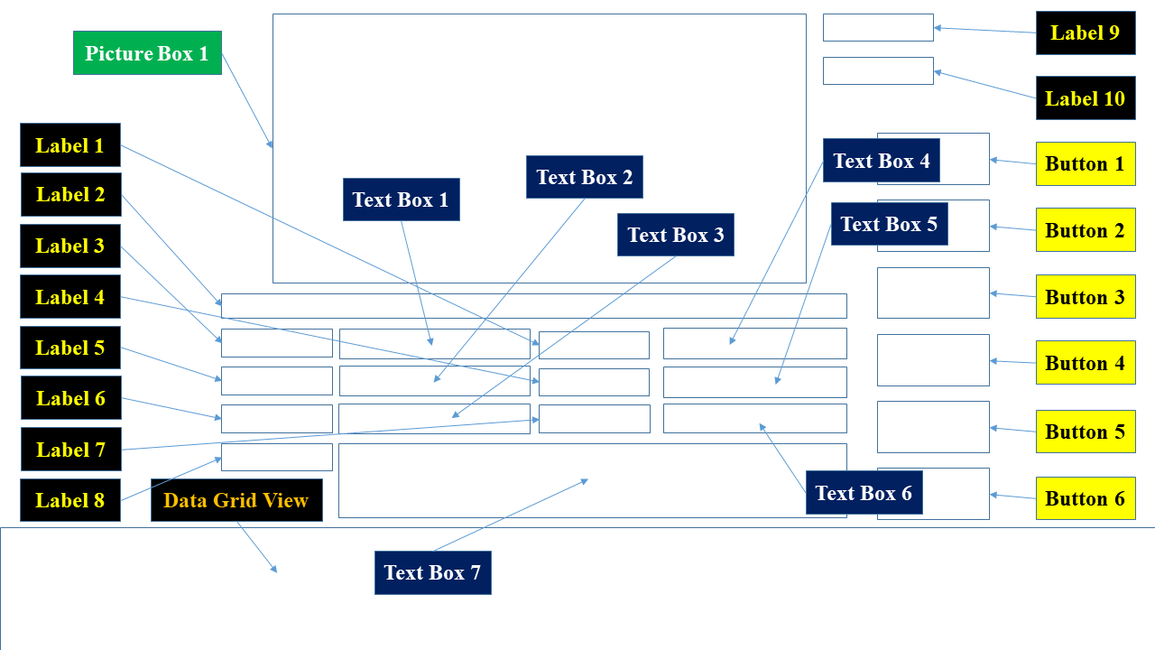

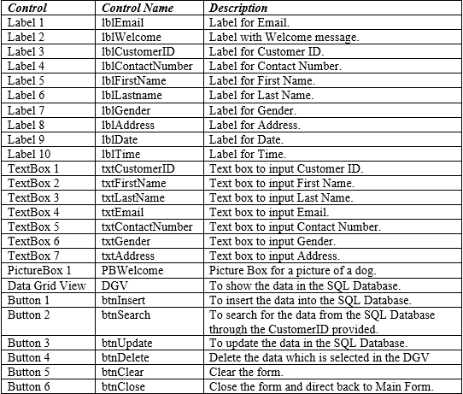

## **2.6 Payment History Form**

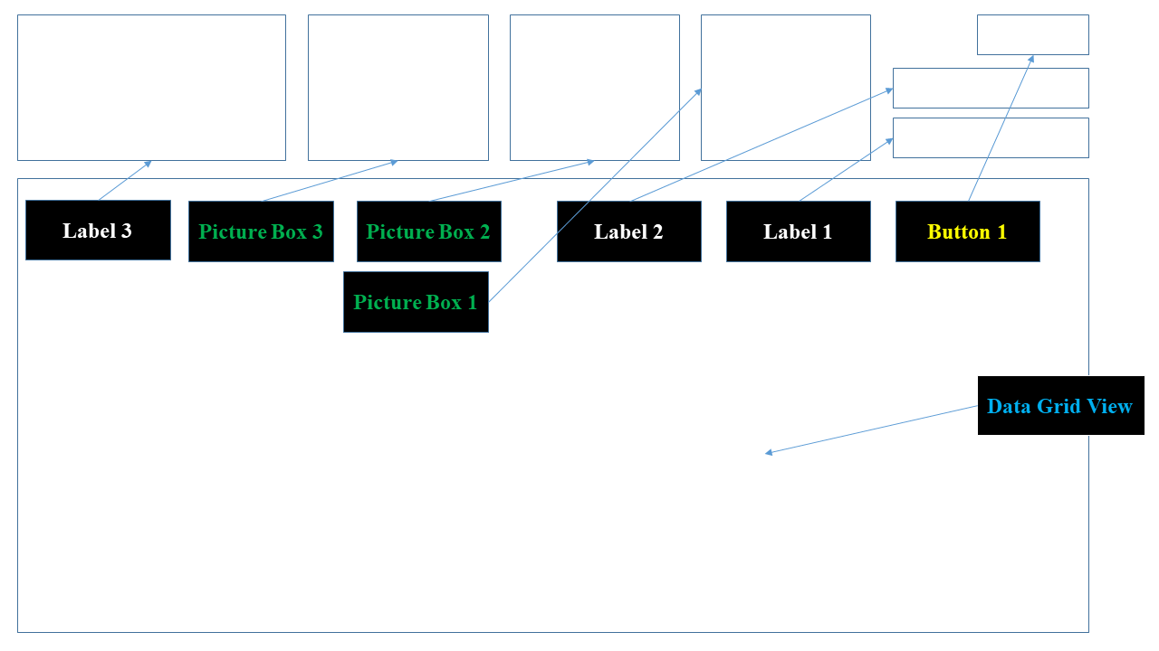

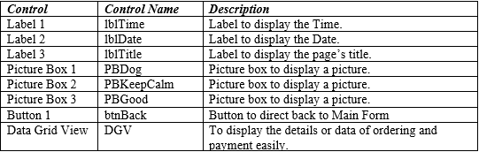

# **3.0 User Manual**

## **3.1 Login Function**

Firstly, users who wants to **access** into the main system have to possess the valid authorization. To do this, users have to provide their identification (username) and authentication (password) through inputting into the textboxes provided (as shown in ***Figure 1***) and if users want to check whether their input for password is correct, user can check the **show password option** to display the passwords in text (as shown in ***Figure 2***)

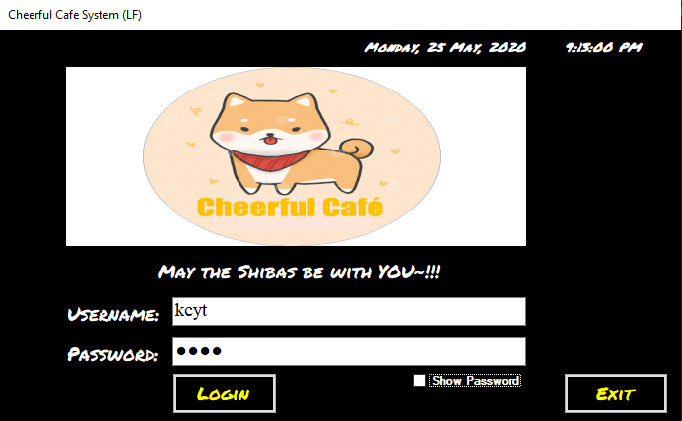

***Figure 1*** *shows the input of username and password.*

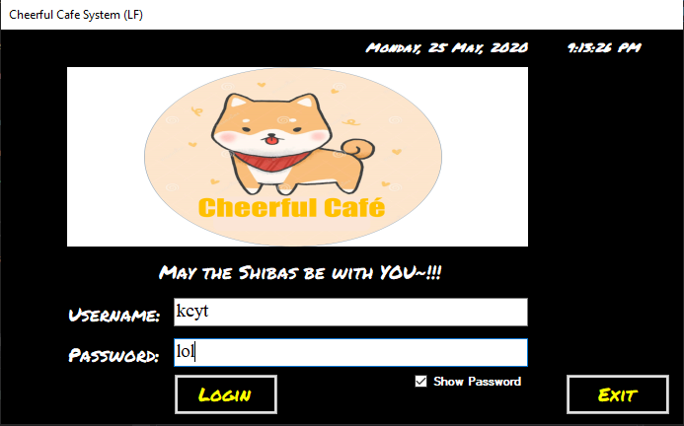

***Figure 2*** *shows the show password option checked and password is shown in text form.*

After inputting, the system will verify the information provided. If **valid**, user will be greeted with a message box, welcoming the user back and granted access to the system’s main menu (as shown in ***Figure 3 & 4***). If **invalid**, user will be shown a message box displaying error in either the username or password (as shown in ***Figure 5***).

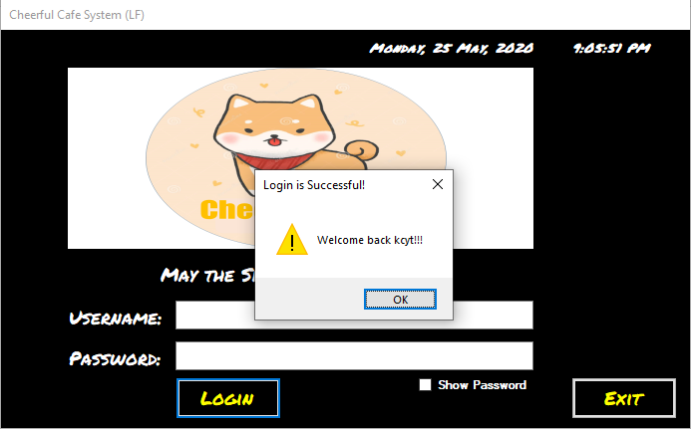

***Figure 3*** *shows message box displayed after login is successful.*

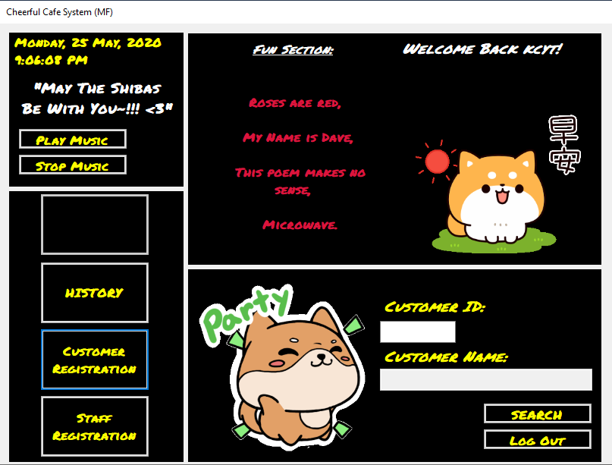

***Figure 4*** *shows the system’s main menu.*

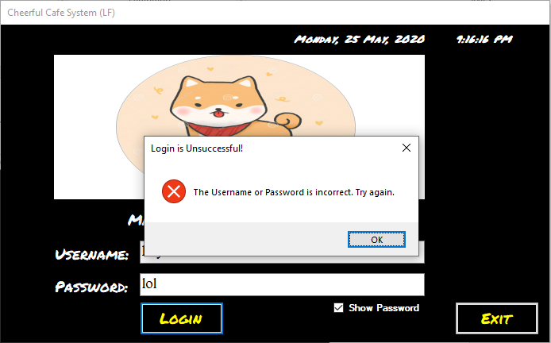

***Figure 5*** *shows message box displayed after login is failed.*

## **3.2 Main Menu Directing to other forms**

In the main menu, user (staff) is able to **direct** themselves to many different pages (***menu, customer & staff registration and history pages***) (as shown in ***Figure 6***).



***Figure 6*** *shows the system’s main menu with various option.*

## **3.3 Playing Music**

The “**play music**” button when clicked by the users is able to play the collection of music pre-loaded into the system in random and the “**stop music**” button when clicked by the users is able to stop the music that is being played (as shown in ***Figure 7***).



***Figure 7*** *shows the “play music and stop music” buttons.*

## **3.4 Enabling “Menu” Option**

To access the “**Menu**” **option** which is disabled, firstly, user has to first input the customer ID into the textbox provided and then press the “search” button to verify the customers identity (as shown in ***Figure 8***).



***Figure 8*** *shows the “Menu & Payment” disabled as Customer is not verified yet.*

Thirdly, after verifying the customer’s identity, the **menu** option will be **enabled** (as shown in ***Figure 9***) for the user to access to the “menu” form to start taking customer’s orders.

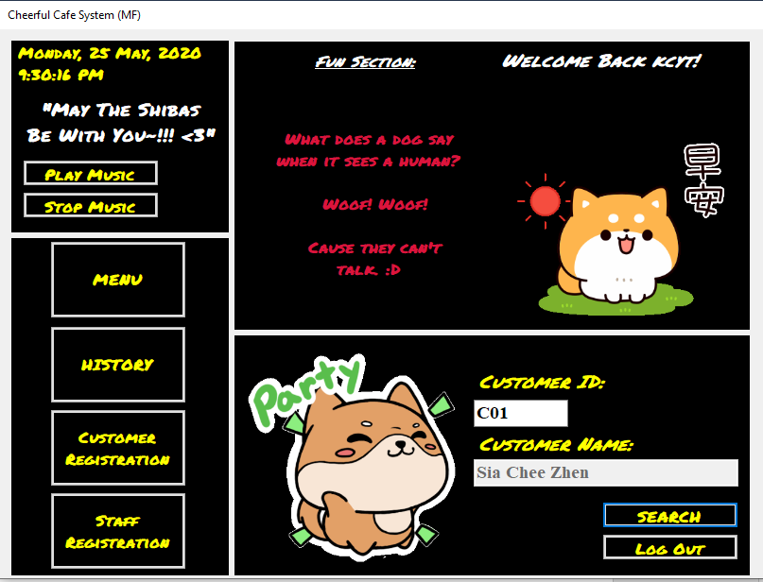

***Figure 9*** *shows the “menu” option enabled after verifying customer’s identity.*

When the “**menu**” option is selected, user will be directed to the menu form (as shown in ***Figure 10***). Whereas if “**History**” option is selected, user will be directed to the history form (as shown in ***Figure 11***). “**Customer Registration**” option will direct user to the customer registration form (as shown in ***Figure 12***). On the other hand, “**Staff registration**” option if selected will direct user to the staff registration form (as shown in ***Figure 13***). Last but not least, if the “**Log** **out**” button is selected, user will be directed to the login page (as shown in ***Figure 1***).

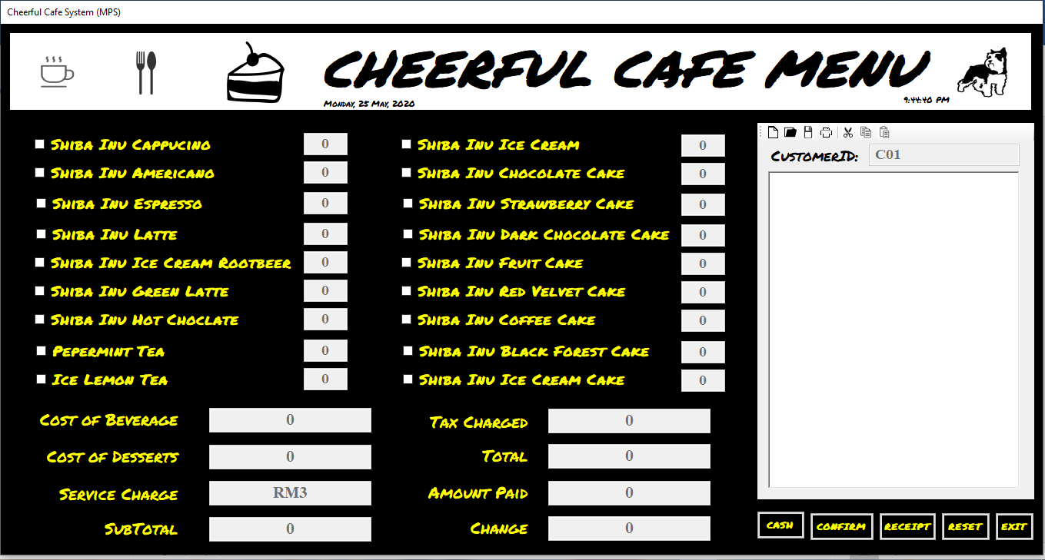

***Figure 10*** *shows the “menu” page.*

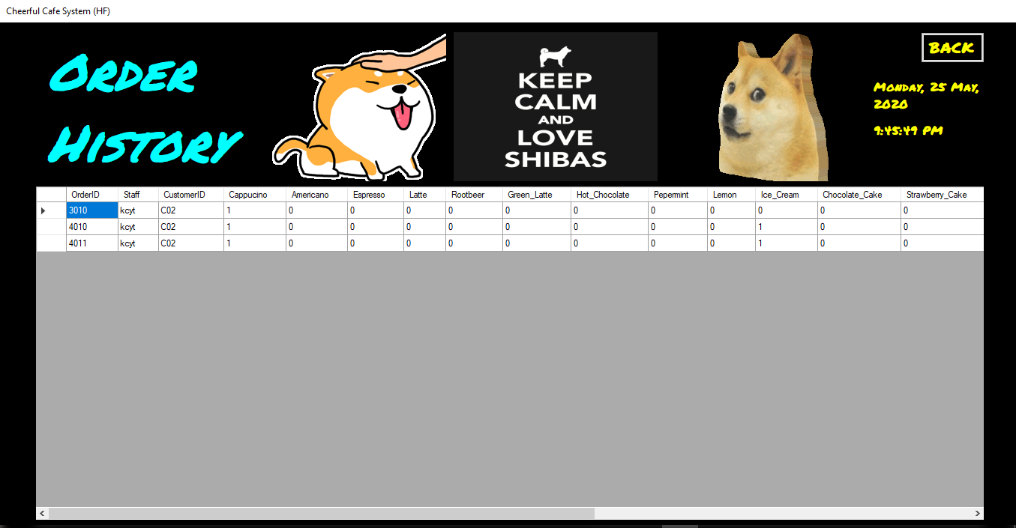

***Figure 11*** *shows the “history” page.*

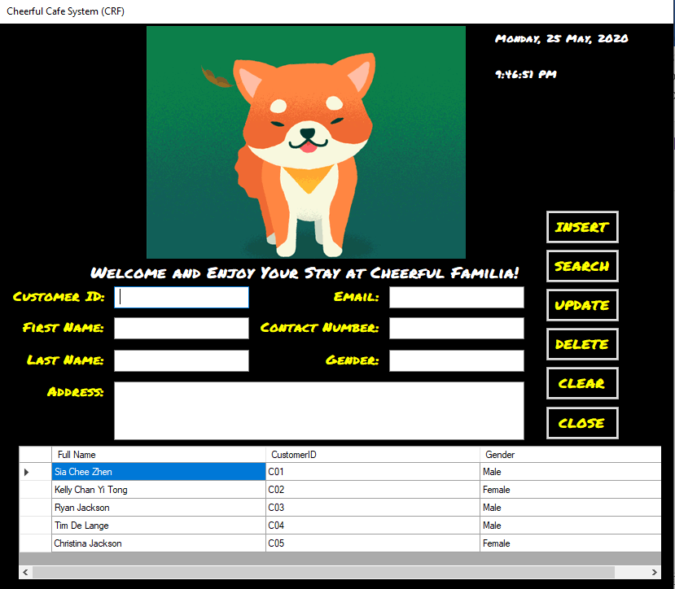

***Figure 12*** *shows the “customer registration” form.*

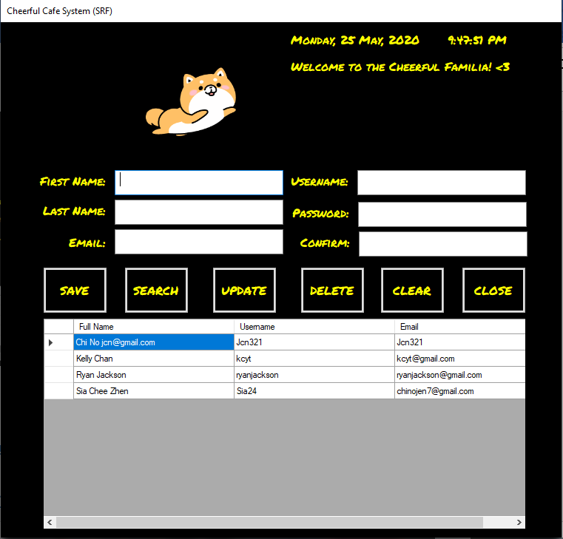

***Figure 13*** *shows the “staff registration” page.*

## **3.5 Ordering and Transactions**

Firstly, after accessing the “**menu**” page, user is able to start **taking** **customers’** **orders** by **checking** the **checkboxes’** of the items’ names and inputting the item’s quantity in the textboxes provided (as shown in ***Figure 14***).

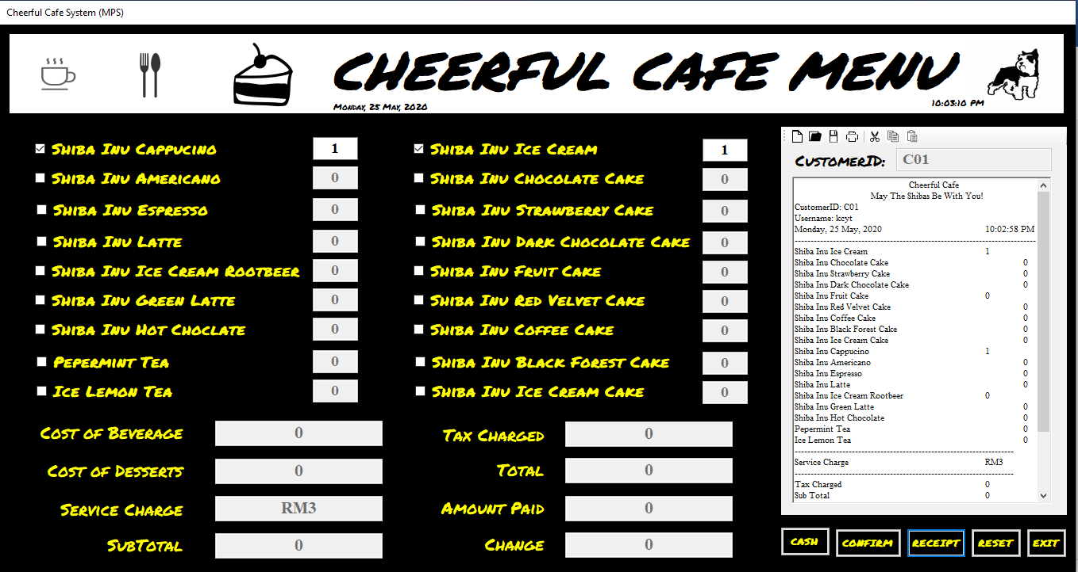

***Figure 14*** *shows the café’s menu.*

Then, user can review the items taken so far by pressing the receipt button to display the list of items ordered and its quantities (as shown in ***Figure 15).***



***Figure 15*** *shows the items and its quantities displayed after “receipt” button is pressed.*

Once the user finished taking the customers’ orders, user have to press on the “**confirm**” button to calculate the ***cost of beverage, desserts, subtotal (inclusive of the service charge, exclusive of tax charged), tax charged and total.*** Then,a message box will firstly ask the user if they are sure to proceed to payment (as shown in ***Figure 16***). If user pressed the “**yes**” option, items’ checkboxes will be disabled and everything mentioned above will be calculated and items and aforementioned cost and many more will be displayed in the receipt rich text box on the right (as shown in ***Figure 17***). Whereas if the “**no**” option is selected, a message box will be displayed to ask user to make changes and users will be able to make changes to the orders (as shown in ***Figure 18***).

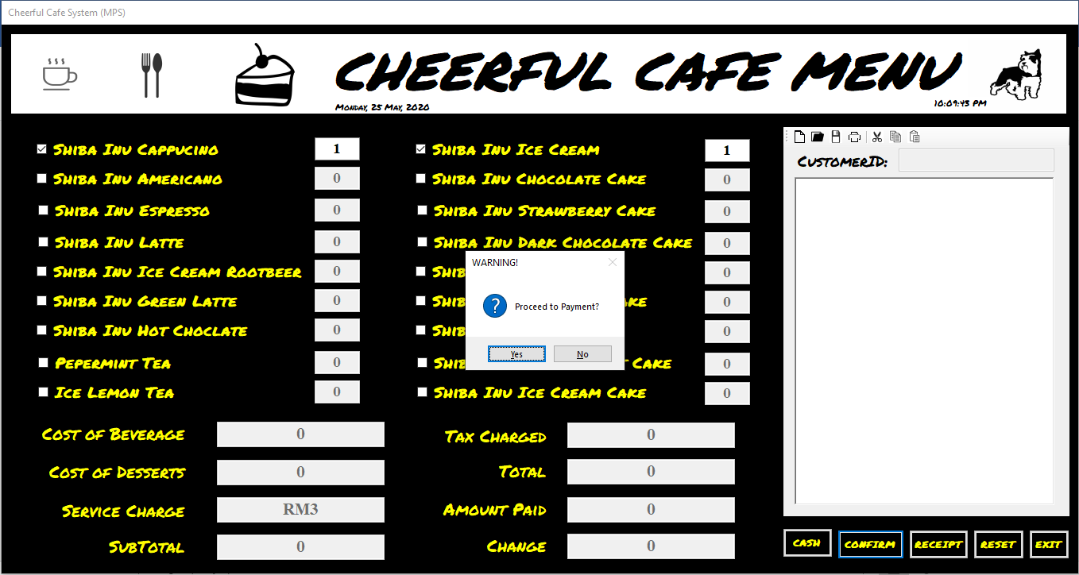

***Figure 16*** *shows “yes” or “no” options for users to select after “confirm” button is pressed.*

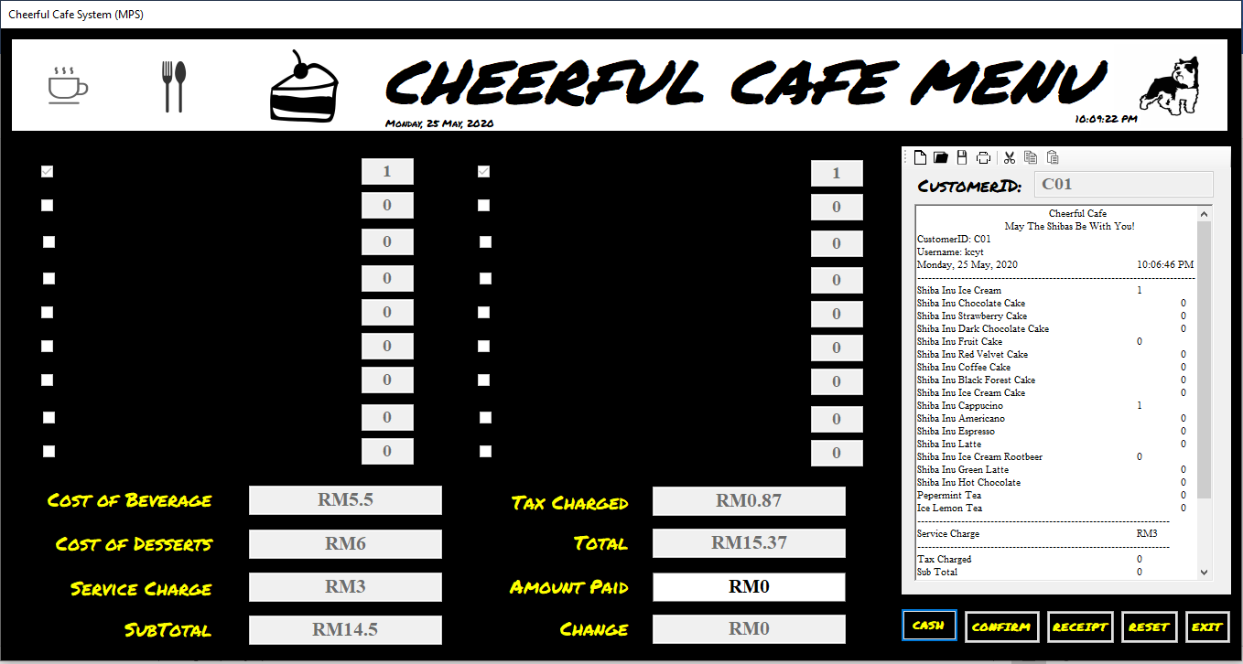

***Figure 17*** *shows checkboxes are disabled after “yes” option is selected.*

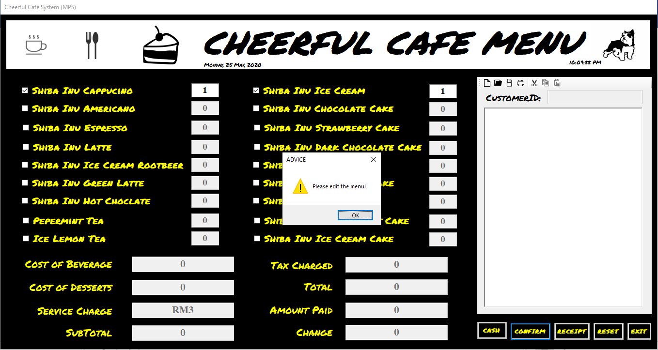

***Figure 18*** *shows items’ checkboxes and textboxes still editable after pressing “no” option.*

Next, after user confirmed the order and wish to proceed to payment, user just have to **input** the **amount** **paid** by the customer in the textbox provided and **click** on the “**cash**” **button,** change will be calculated and displayed in the designated textbox (as shown in ***Figure 19***). Lastly, after the button is pressed, a message box with the message “transaction is saved successfully will be displayed (as shown in ***Figure 19***) and the receipt will be shown in the printing format (as shown in ***Figure 20***). If user do not wish to print the receipt, he can just press on the “**Close**” button (as shown in ***Figure 20***) and the **whole** **form** will be **reset** to its original state, clearing textboxes, checkboxes and receipt rich text box (as shown in ***Figure 21***). Whereas, after user printed the receipt, the form will be reset too.

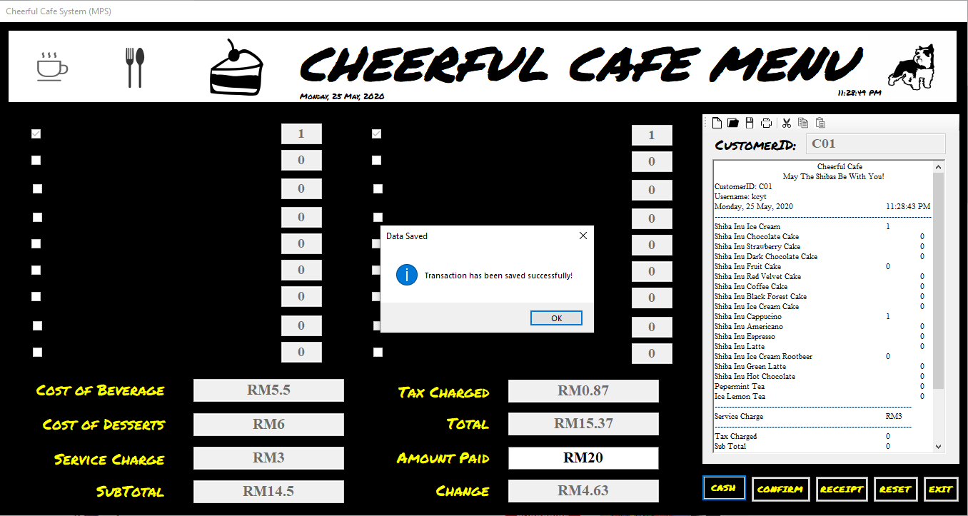

***Figure 19*** *shows the message box after “cash” button is pressed.*

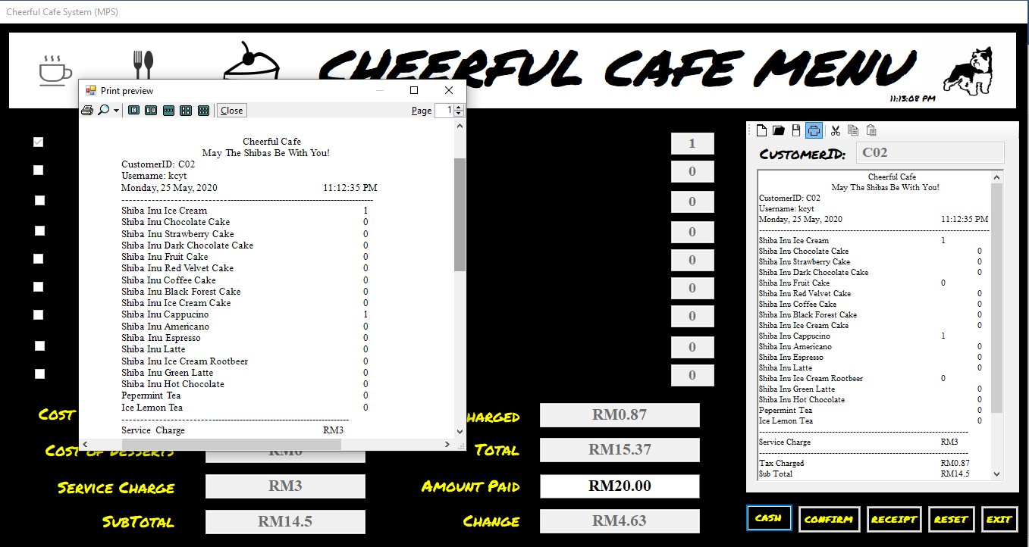

***Figure 20*** *shows the receipt displayed in receipt format.*

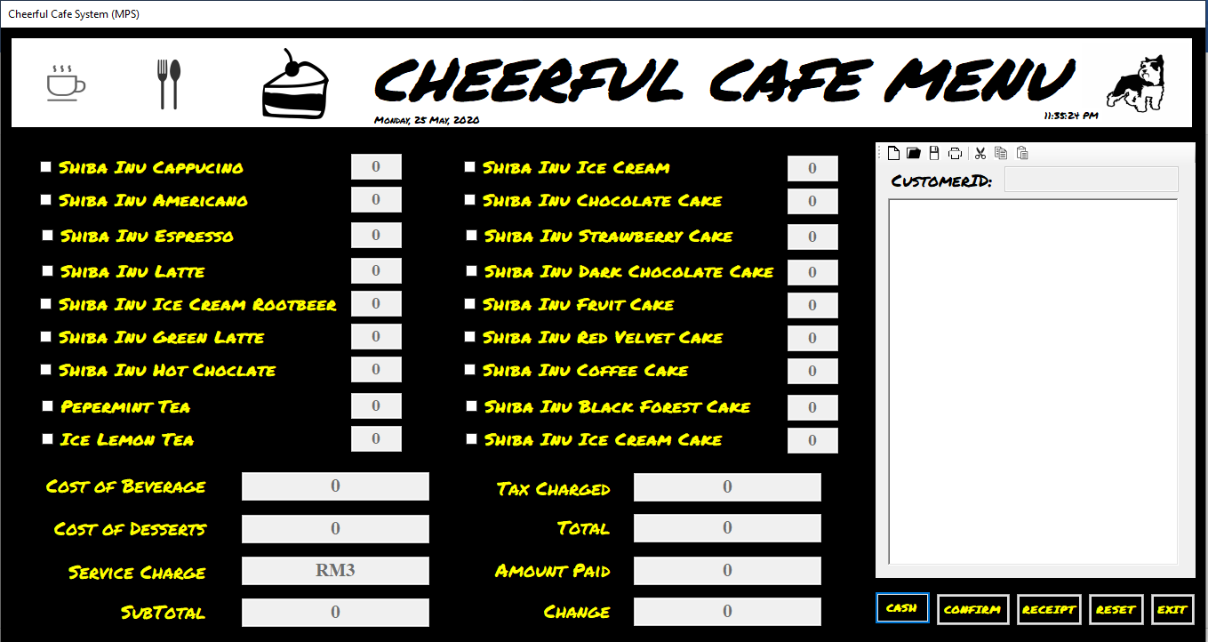

***Figure 21*** *shows the form reset to its original state.*

## **3.6 Extra Relevant Functions (Menu)**

Other relevant functions includes, user able to use the “**reset**” button to reset the whole form to its original state (as shown in ***Figure 22***), “**exit**” button to return to the system’s main menu (as shown in ***Figure*** ***22***) and **extra** **tools** (***new receipt page, open receipt saved, save, print, cut, copy and paste functions***) provided to user at the top of the receipt rich textbox as shown in ***Figure*** ***22***). The “new receipt page” is to present a new blank receipt rich text box page when pressed. “open receipt saved” icon

**

***Figure 22*** *shows the “reset”, “exit” and extra tools buttons.*

## **3.7 Registration (Staff)**

The “**staff** **registration**” page (as shown in ***Figure*** ***23***) is used to register new staff members, so that they are granted authorized access to the system.

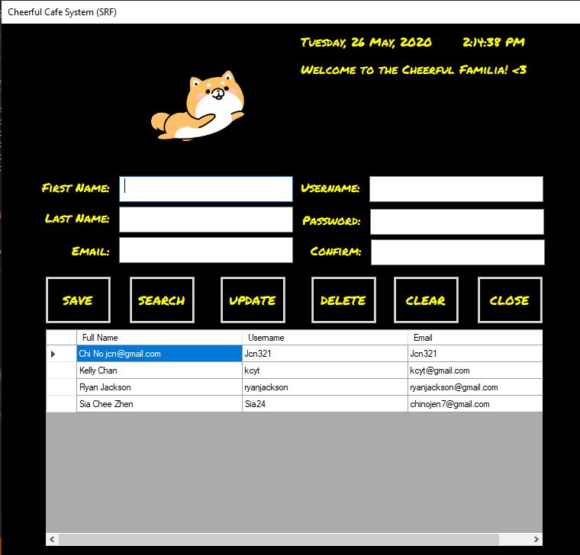

***Figure 23*** *shows the “staff registration” page.*

Firstly, the user has to first input all the necessary details (***First Name, Last Name, Email, Username, Password, and Password Confirmation***) in the textboxes provided (as shown in ***Figure 24***).

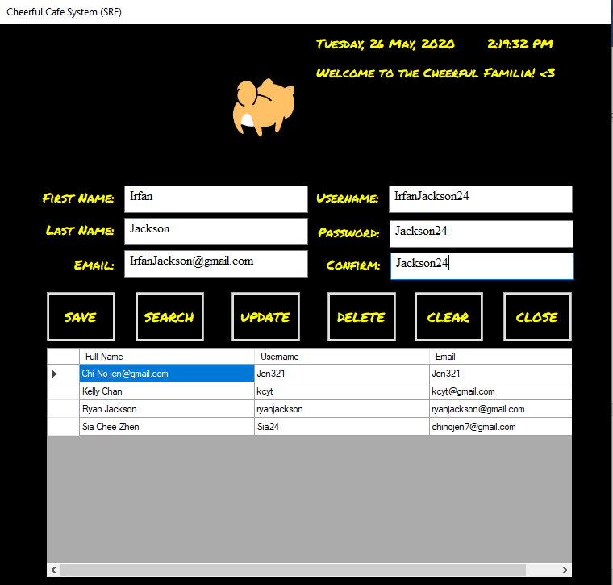

***Figure 24*** *shows the input of details into the textboxes provided.*

After the details are inputted, user has to press the “**save**” button to register the details provided into the database as a record, a message box will display the saving of data is successful (as shown in ***Figure*** ***25***). Then, the info will be displayed in the data grid view and all textboxes will be reset (as shown in ***Figure*** ***26***).

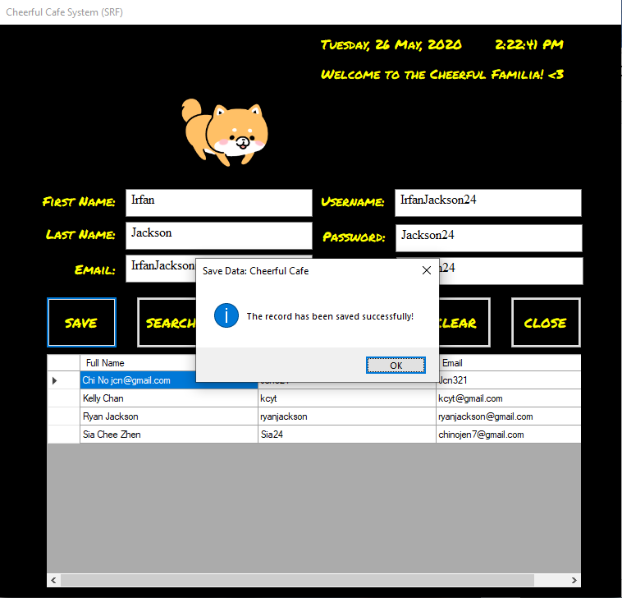

***Figure 25*** *shows the message displaying saving of data is successful.*

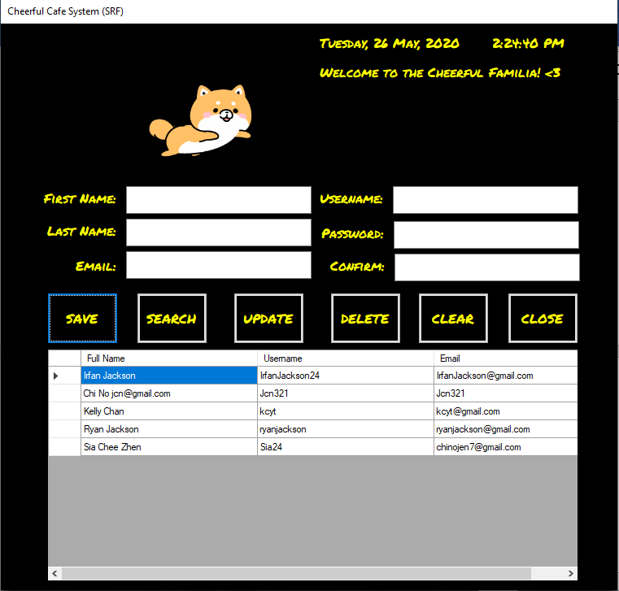

***Figure 26*** *shows the textboxes are all cleared and details inputted earlier is displayed in the data grid view.*

## **3.8 Search and Update Function (Staff)**

The function of the “**search**” button is for the user to input the username of the staff and details of the staff will be displayed in the textboxes (as shown in ***Figure*** ***27***). After the staff’s details are displayed, user is able to change the details of the staff and pressing on the “**update**” button will replace the details in the database and in the data grid view to the ones inputted in the textboxes (as shown in ***Figure*** ***28***).

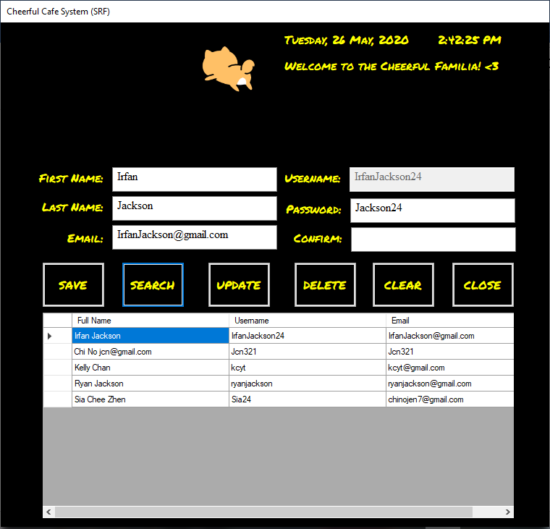

***Figure 27*** *shows details of Irfan Jackson after username input and pressing “search” button.*

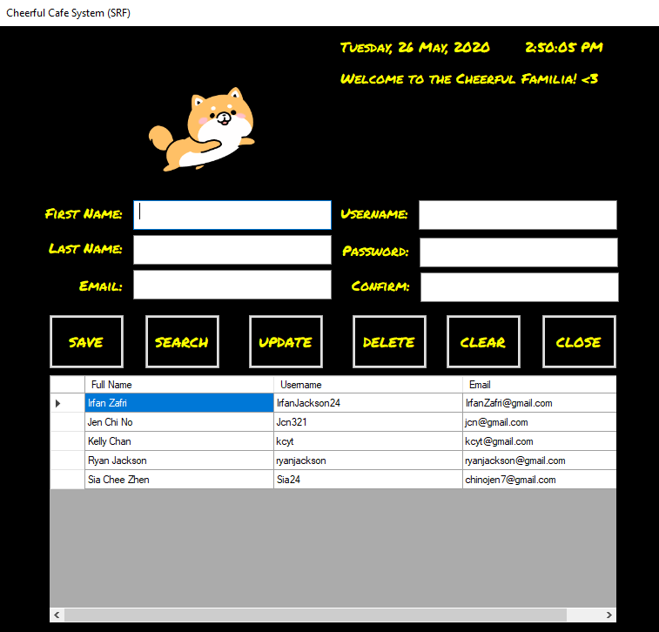

***Figure 28*** *shows the details in the data grid view is changed after the update.*

## **3.9 Extra Relevant Functions (Staff)**

The “**delete**” button is used by user to delete the data they don’t want. All they need to do is select the data they want to delete on the data grid view and press the “**delete**” button. Upon pressing, the data will be deleted and a message box will display saying the data is deleted successfully (as shown in **Figure** **29** and **Figure** **30**). The “**clear**” button is just to reset the form to its original state, clearing textboxes (as shown in **Figure** **31**) and the “**close**” button directs user back to the “main menu” page.

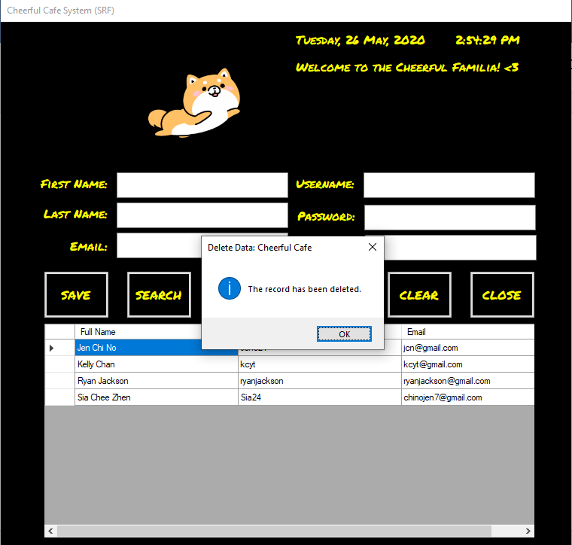

***Figure 29*** *shows a message box displayed after successful delete of data.*

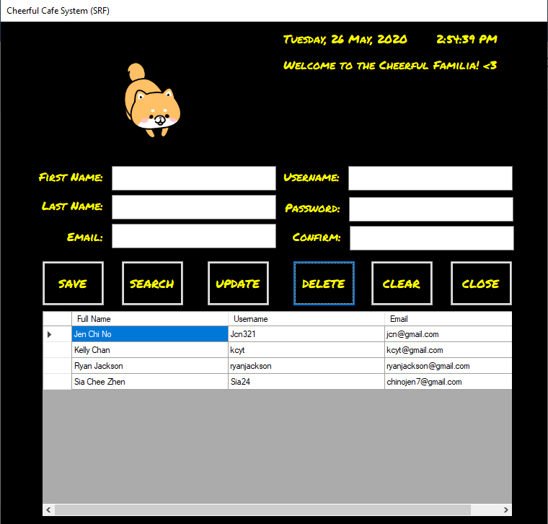

***Figure 30*** *shows the details of staff, Irfan Zafri deleted.*

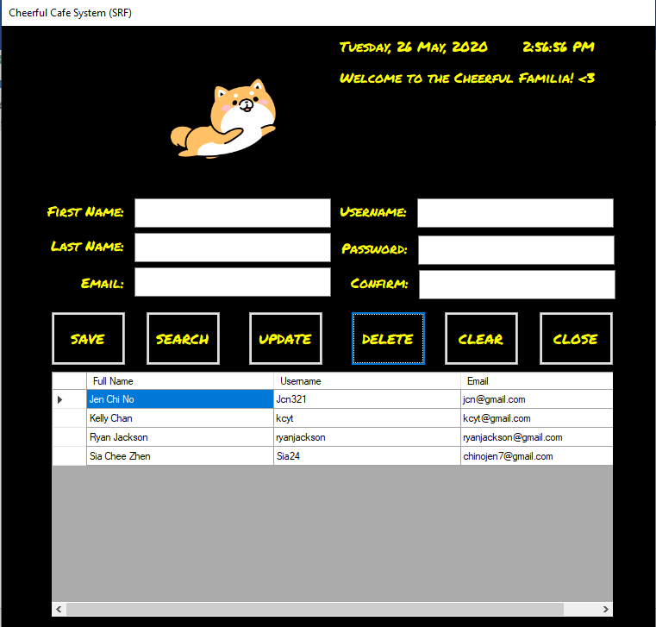

***Figure 31*** *shows the “staff registration” page reset to its original state after pressing the “clear” button*

## **3.10 Registration (Customer)**

The “**customer** **registration**” page (as shown in ***Figure*** ***32***) is used to register new customers, so that the staffs are able to take their orders.

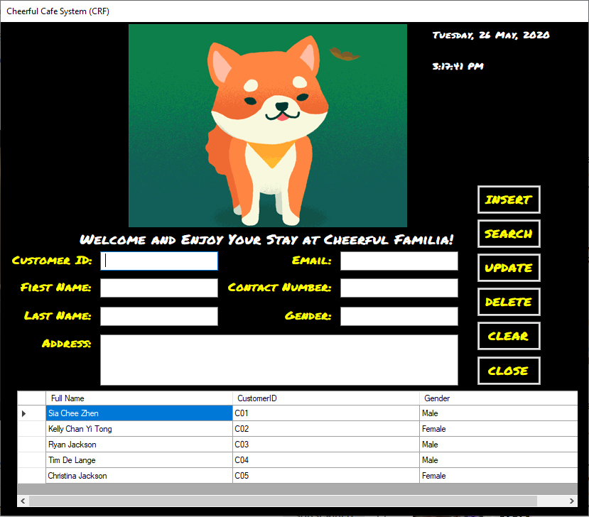

***Figure 32*** *shows the “customer registration” page.*

Firstly, the user has to first input all the necessary details (***First Name, Last Name, Email, Customer ID, Contact Number, Gender and Address***) in the textboxes provided (as shown in ***Figure 33***).

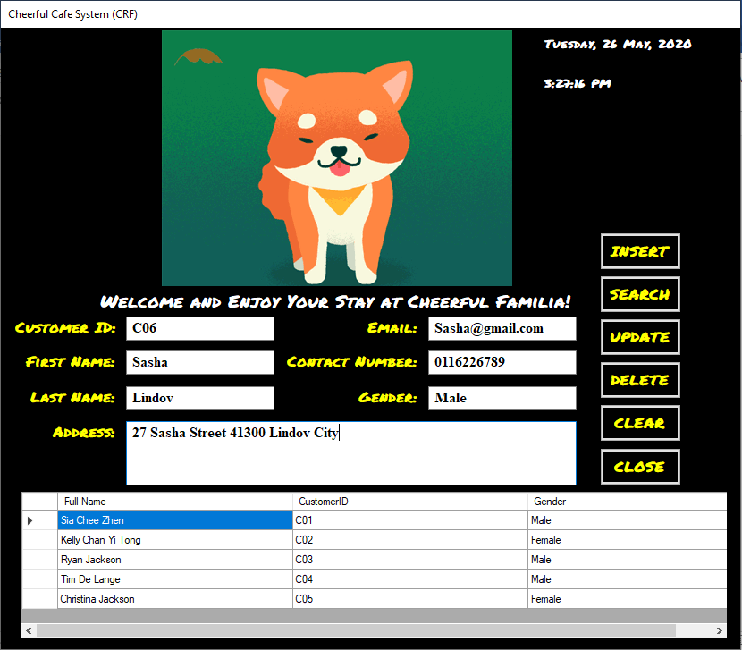

***Figure******33*** *shows the input of details in the textboxes.*

After the details are inputted, user has to press the “**insert**” button to register the details provided into the database as a record, a message box will display the saving of data is successful (as shown in ***Figure*** ***34***). Then, the info will be displayed in the data grid view and all textboxes will be reset (as shown in ***Figure*** ***35***).

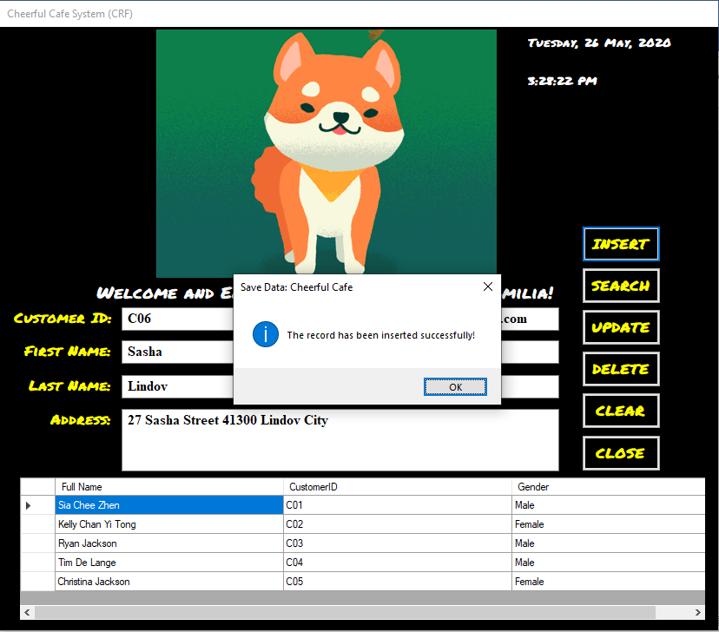

***Figure 34*** *shows the successful saving of Sasha’s details displayed in the message box.*

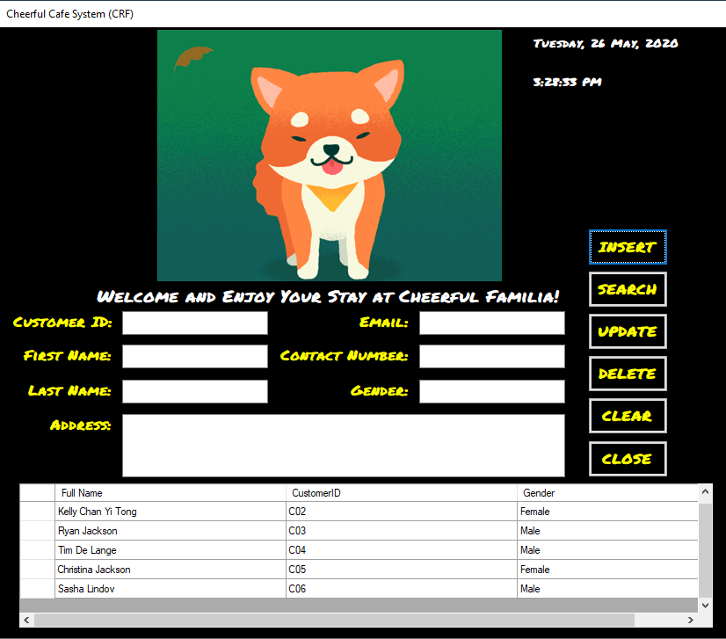

***Figure 35*** *shows Sasha’s information displayed in the data grid view.*

## **3.11 Search and Update Function (Customer)**

The function of the “**search**” button is for the user to input the customer’s customer ID and details of the customer will be displayed in the textboxes (as shown in ***Figure*** ***36***). After the customer’s details are displayed, user is able to change the details of the customer and pressing on the “**update**” button will replace the details in the database and in the data grid view to the ones inputted in the textboxes (as shown in ***Figure*** ***37***).

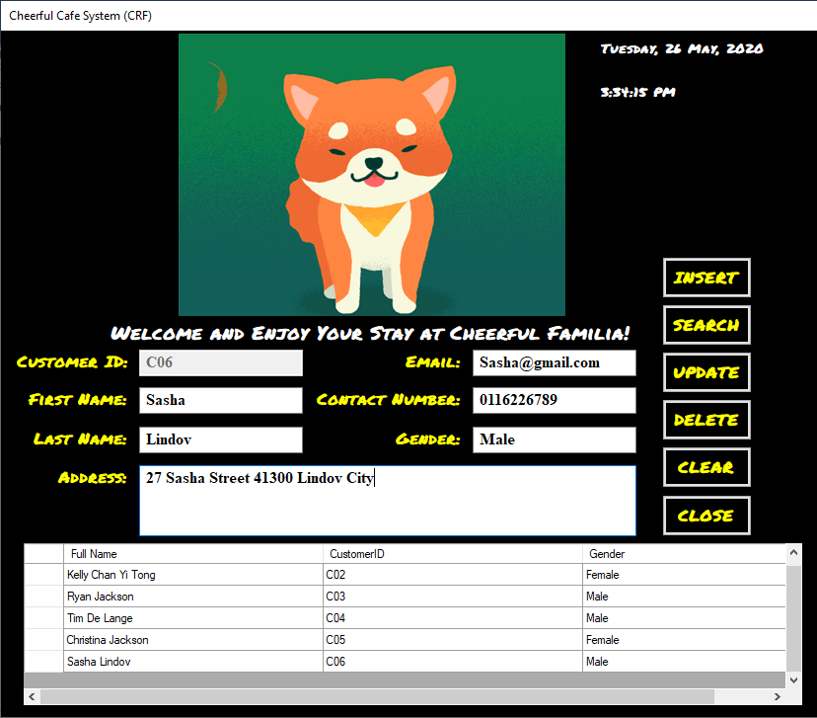

***Figure 36*** *shows the details of customer, Sasha Lindov displayed after input of Customer ID and pressing of the “Insert” button.*

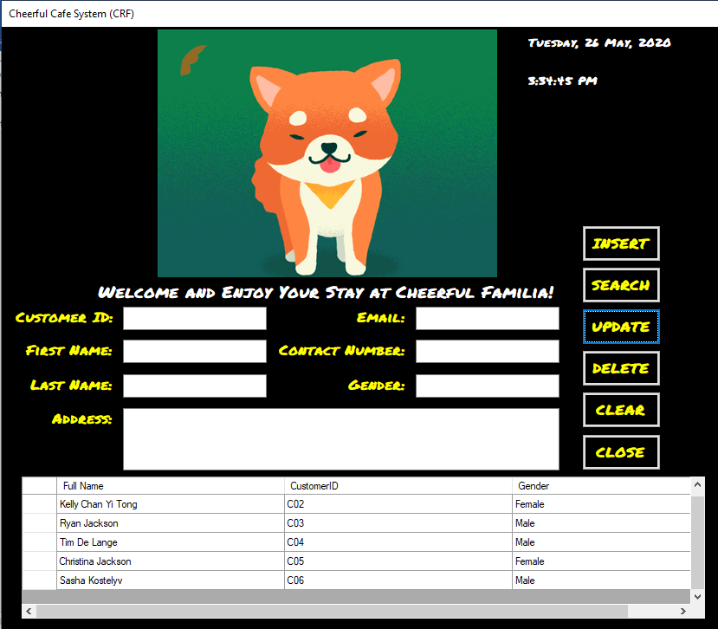

***Figure 37*** *shows the name of the customer, Sasha Lindov updated to Sasha Kostelyv and displayed in the data grid view.*

## **3.12 Extra Relevant Functions (Customer)**

The “**delete**” button is used by user to delete the data they don’t want. All they need to do is select the data they want to delete on the data grid view and press the “**delete**” button. Upon pressing, the data will be deleted and a message box will display saying the data is deleted successfully (as shown in **Figure** **38** and **Figure** **39**). The “**clear**” button is just to reset the form to its original state, clearing textboxes (as shown in **Figure** **40**) and the “**close**” button directs user back to the “main menu” page.

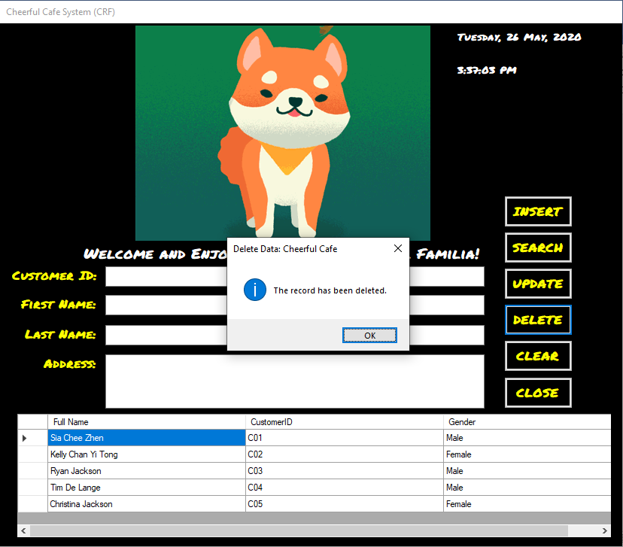

***Figure 38*** *shows the message box displaying successful delete of data.*

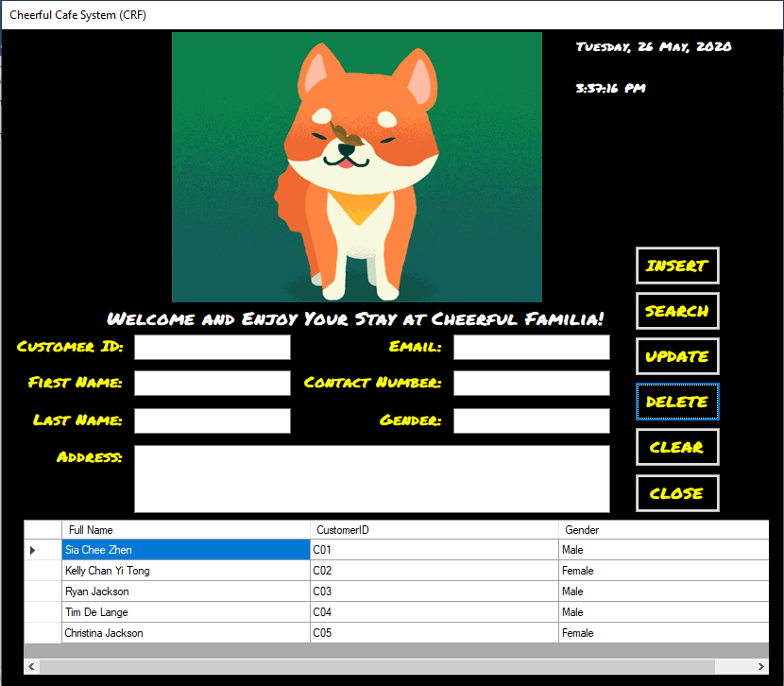

***Figure 39*** *shows the data of Sasha Kostelyv deleted and not in the data grid view.*

**

***Figure 40*** *shows the page reset after the “clear” button is pressed.*

## **3.6 Transaction History**

The “**history**” page (as shown in ***Figure*** ***41***) is used by the user to look at past transactions made, if customers demand for it. The “**back**” button is used by users to direct back to the “**main** **menu**” page.

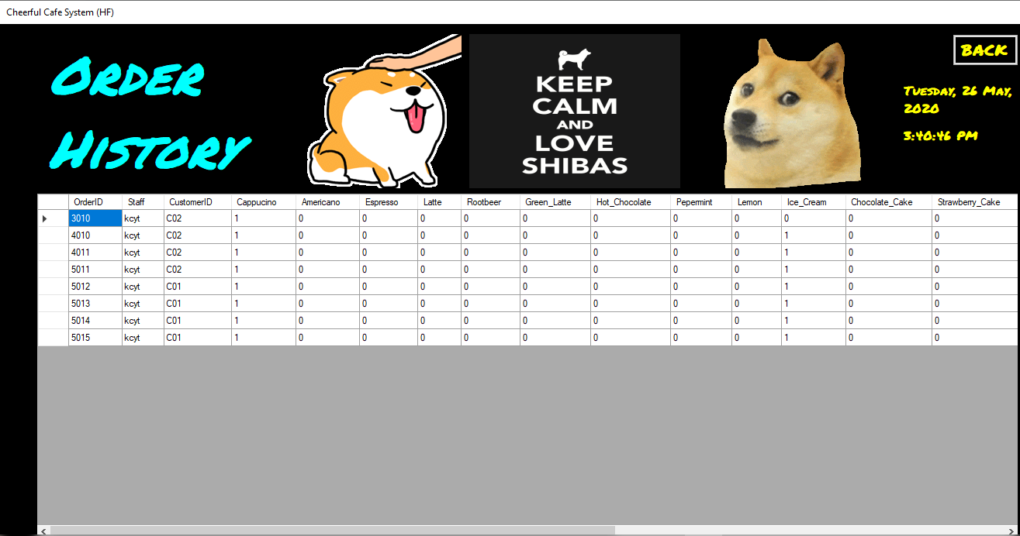

***Figure 41*** *shows the “history” page.*

# **4.0 Testing**

|  |  |  |  |  |  |
| --- | --- | --- | --- | --- | --- |
| **Test Case** | **Function Name** | **Test Objective** | **Expected Result** | **Actual Result** | **Remarks** |
| ***1*** | **Login Button** | When button is pressed, upon correct input of username and password, user will be granted access to the system and directed to the main form. | User is granted access to the system and directed to the main form upon successful login. | User granted access to system after password and username matches the one in the database and is then directed to the main form. | None. |
| ***2*** | **Show Password** | When the checkbox is checked, password textbox characters which are in the form of “ ******** “ will be displayed in normal alphabetical and numerical characters instead of system password characters and when unchecked, it returns to system password characters. | User is able to see what the alphabetical and numerical characters inputted into the textbox upon checking the show password checkbox and when unchecked, the characters return to system password characters’ form. | User is able to see what was inputted into the textbox after the checkbox is checked and when unchecked, the text In the textbox returned to system password characters. | None. |
| ***3*** | **Insert (Customer Registration)** | When insert button is pressed, the data inputted in the textboxes available is saved into the database and a message box showing “data is saved successfully” is displayed. | Data will be inserted into the database and message box displaying the intended message is displayed and when the database is viewed, the data can be found. | Data is inserted into the database and the message box popped up displaying the message mentioned and when viewed in the database, the data can be found and viewed. | None. |
| ***4*** | **Cash Button** | When the cash button is pressed, the subtotal’s, total’s, tax charged’s and change’s values will be displayed in the textboxes, the items ordered and other transaction details will be saved into the database. | After pressing, the values are displayed in the textboxes and all transactions details including items ordered will be saved into the database. | Values are displayed in the textboxes as expected and all transaction details are saved into the database as a message box “data is saved successfully!” displayed as a notification. | None. |
| ***5*** | **Receipt Button** | When pressed, the list of item names, quantity, subtotal, tax charged, total, amount paid, changed and many other details will be displayed in the rich text box provided in the correct format. | List of items with the quantity and many other details mentioned will be displayed in the rich text box in the correct format when the Receipt button is pressed. | Aforementioned items and conditions are all displayed in the rich textbox and met as expected and in the correct format. | None. |
| ***6*** | **Search Button (Main Form)** | After inputting of customer ID and pressing of the search button, customer’s name will be fetched from the database and displayed in textbox provided, and the menu button will be enabled. | Customer’s name is displayed and menu button is enabled after inputting of customer ID and pressing of search button. | Customer’s name is displayed in the textbox provided and the menu button is enabled, and able to be pressed to direct to the Menu Page after the pressing of search button after inputting of customer ID. | None. |
| ***7*** | **Play Music Button** | After pressed, a song will be played randomly from the collection of songs available. | Song will be played after the play button is pressed. | Music can be heard after the pressing of the play music button. | None. |
| ***8*** | **Update Button (Staff Registration)** | After inputting of necessary details and pressing of the update button, a notification of “data is updated successfully” will be shown and information inputted will replace the data of the intended replacement in the database. | After pressing the button, notification is shown in the form of a message box and the data in the database is updated. | The data in the database is updated after the button is pressed and a notification in the form of a message box, displaying “data is updated successfully” popped up. | None. |
| ***9*** | **Logout Button** | After pressing, user will be directed to the login page. | Directed to the login page after pressing the button. | After pressing the button, the main form closes and is directed to the login page. | None. |
| ***10*** | **Exit Button (Login Form)** | After pressing, application will close. | Application will close after pressing. | Upon pressing the “exit” button, the application closes. | None. |

# **5.0 Critical Assessment**

## **5.1 Strengths**

There are many **strengths** that are possessed by this system. One of the many strengths is that this system is designed to be **simple** to be used by employees and the owners as most of the functions can be **learnt** by employees **within** as aforementioned **few** **days** or **one** **week**, it is **not** **difficult** or **complicated** at all. Besides that, this system also provides **high** **efficiency** in terms of **managing** the **orders** and **transactions** of **customers**, saving time being wasted in employees needing to engage customers personally to get their order jotted down and ordered. In addition, it is also very **accurate** in terms of **calculation** for the ***total charged***, ***tax charged***, ***change*** given back to customers and many more, instead of relying on our mental calculation, which reliability is 50%, due to human errors. Besides that, a **history** **page** (as shown in ***Figure*** ***43***) is present for staffs and owner to review past transactions that were saved in a database right after the transaction is made (as can be seen in ***Figure*** ***42***). Whereas if this was traditionally done, receipts would have been written by hand and requires a lot of efforts and time. Also, sometimes it will not be accurate and this can lead to the issues of customers coming back to demand for a refund which they are not entitled to, which is due to errors made during the writing of the receipt.

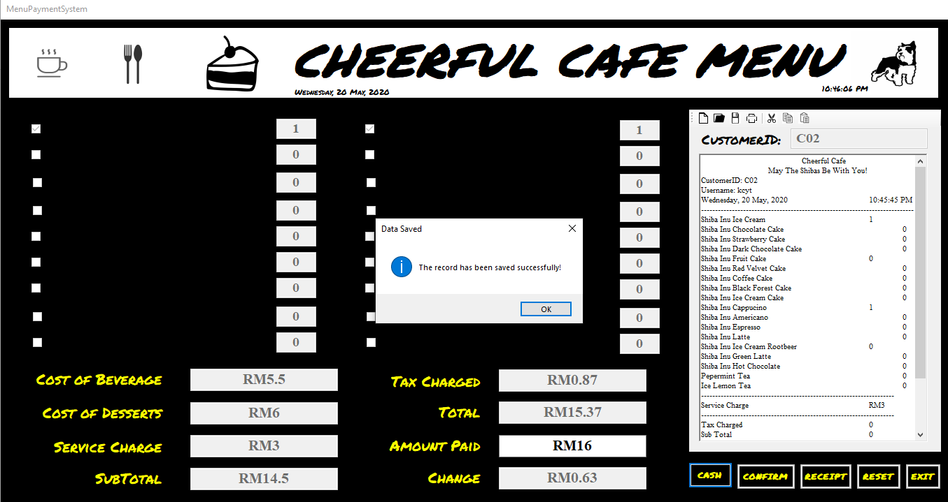

***Figure 42*** *shows the saving of transaction into the database right after it is made.*

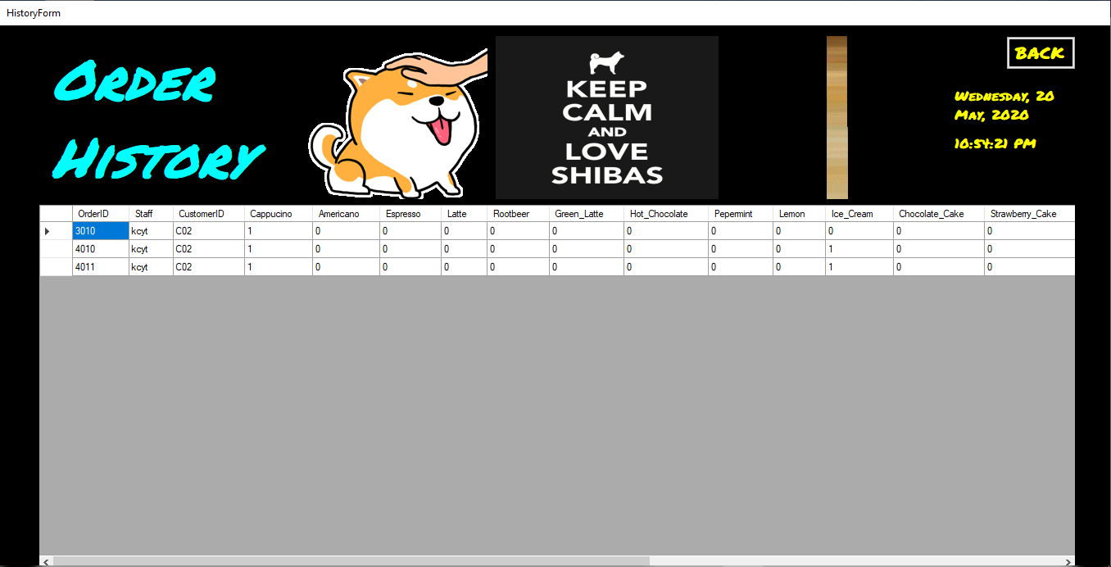

***Figure 43*** *shows the History Page in which previous transactions can be reviewed.*

## **5.2 Weaknesses**

There are few **weaknesses** in the system worth mentioning. One of the few weaknesses in the system is the **security**. This is because the system is easily **hackable** or **accessible** as there are **absent** of **extra-authentication factors** (as can be seen in ***Figure*** ***45***) such as the two-factor authentication, three-factor authentication, four-factor authentication and many more which will reduce the difficulty for trespassers to trespass into the system with ease. Besides that, a “**Forgot your Password**” function is not available yet on the login page (as shown in Figure A) as it is not implemented yet. Thus, if employees forgot their password, they will **require** the **manager** to be able to **access** into the main menu to direct to the staff registration page to **change** their **password** for them. In addition, a **discount** **function** is not present (as can be viewed in ***Figure*** ***44***) which if the employee or the owner of the store will like to offer to their customers, it is **not** **possible** to be done. Last but not least, the current payment method available in the system is **cash** as **electronic** **payment** **methods** which is a trending one right now in this modern era **isn’t** **implemented** yet in the system. Thus, this will make it more difficult for the customers to make payment as they have to bring cash when visiting the café.



***Figure 44*** *shows the unavailability of the discount function.*

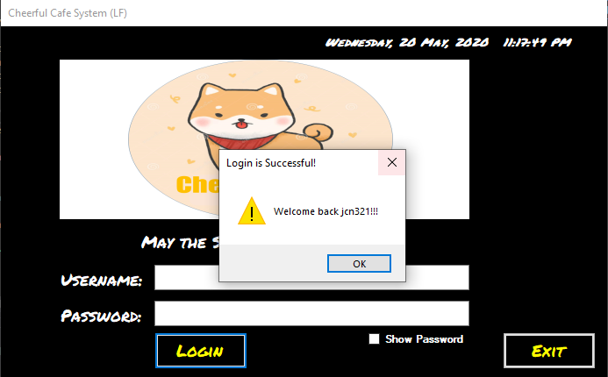

***Figure 45*** *shows that extra authentication factor is not needed, just the password and “Forgot Your Password” function is not available.*

## **5.3 Recommendation for Future Updates**

There are few **recommendations** which I will like to implement in the future updates. One of them will be to implement a **“Forgot Your Password” function** to allow staffs to change their passwords through **addition** of another **form** which contains questions and staffs will require to answer before able to **change** their **passwords**, which will then reduce the **reliance** of staff on the **owner** to access the system to change their passwords for them. In addition, I will also like to implement a **two or three or four factor authentication** in the future so that the **security** of the system will not be that easily compromised and be accessed by non-employees or criminals who are trying to steal employees’ data, data on transactions and many more. Besides that, a **discount** **function** will also be one of the main future implementation as it allows owners to give discounts to their loyal customers. Furthermore, I will also like to **improve** the **rounding** **off** **function** for the total charges and changes given back. This is to make sure that the values are either divisible by 5 or 10 to make sure that numbers such as 1 to 8 wouldn’t exist at the second decimal place of the value. For example (as can be viewed in ***Figure*** ***46***), the change is RM 0.63, total is RM 15.37 due to the tax charged being RM0.87. Thus what I plan to do is to make sure that the total will be like “RM 15.40” instead of “RM 15.37” and “RM 0.65” instead of “RM 0.63”.



***Figure 46*** *shows a transaction made by customer with ID, C02.*

# **6.0 References**

1. Achmad, S., 2018. *YouTube.* [Online]   
   Available at: https://www.youtube.com/watch?v=BDoAREFjlCw  
   [Accessed 26 May 2020].
2. Andres, 2013. *Stack Overflow.* [Online]   
   Available at: https://stackoverflow.com/questions/20201537/connecting-to-a-sql-server-database-using-vb-net  
   [Accessed 26 May 2020].
3. blog, 1., 2016. *YouTube.* [Online]   
   Available at: https://www.youtube.com/watch?v=MWP8geR76kI  
   [Accessed 26 May 2020].
4. Blog, 1., 2016. *YouTube.* [Online]   
   Available at: https://www.youtube.com/watch?v=u9DqI0oAzmk&t=503s  
   [Accessed 26 May 2020].
5. BonyT, 2011. *Stack Overflow.* [Online]   
   Available at: https://stackoverflow.com/questions/6138518/count-in-sql  
   [Accessed 26 May 2020].
6. Chingono, A., 2011. *Stack Overflow.* [Online]   
   Available at: https://stackoverflow.com/questions/6835422/how-to-create-html-form-in-a-new-window  
   [Accessed 26 May 2020].
7. Creators, T. S., 2016. *YouTube.* [Online]   
   Available at: https://www.youtube.com/watch?v=OaB2YevBHl8  
   [Accessed 26 May 2020].
8. Duchess, C., 2012. *Stack Overflow.* [Online]   
   Available at: https://stackoverflow.com/questions/13809510/delete-records-from-sql-table-in-vb-net  
   [Accessed 26 May 2020].
9. elixenide, 2017. *Stack Overflow.* [Online]   
   Available at: https://stackoverflow.com/questions/45406613/regex-pattern-for-malaysian-mobile-phone-number  
   [Accessed 26 May 2020].
10. Gray, C., 2010. *Stack Overflow.* [Online]   
    Available at: https://stackoverflow.com/questions/4529862/declare-global-variables-in-visual-studio-2010-and-vb-net  
    [Accessed 26 May 2020].
11. iBasskung, n.d.. *YouTube.* [Online]   
    Available at: https://www.youtube.com/watch?v=cwDqjmSmtMQ&t=48s  
    [Accessed 26 May 2020].
12. Jacot-Descombes, O., 2018. *Stack Overflow.* [Online]   
    Available at: https://stackoverflow.com/questions/49460408/visual-basic-when-inserting-data-in-sql-server  
    [Accessed 26 May 2020].
13. kiLLua, 2017. *Stack Overflow.* [Online]   
    Available at: https://stackoverflow.com/questions/47130433/update-button-codes-for-vb-net-with-sql-server  
    [Accessed 26 May 2020].
14. McDonald, P., 2012. *Stack Overflow.* [Online]   
    Available at: https://stackoverflow.com/questions/1172306/convert-string-to-double-vb  
    [Accessed 26 May 2020].
15. modi123_1, 2008. *dream.in.code.* [Online]   
    Available at: https://www.dreamincode.net/forums/topic/370073-how-do-i-validate-that-at-least-one-checkbox-is-checked/  
    [Accessed 26 May 2020].
16. ProgrammingKnowledge, 2014. *YouTube.* [Online]   
    Available at: https://www.youtube.com/watch?v=cNRgcHxGnfU  
    [Accessed 26 May 2020].
17. ProgrammingKnowledge, 2014. *YouTube.* [Online]   
    Available at: https://www.youtube.com/watch?v=FYVK7HHowFo  
    [Accessed 26 May 2020].
18. RegExLib, n.d.. *RegExLib.com.* [Online]   
    Available at: http://regexlib.com/Search.aspx?k=phone+number&c=-1&m=-1&ps=20  
    [Accessed 26 May 2020].
19. Theraot, 2010. *Stack Overflow.* [Online]   
    Available at: https://stackoverflow.com/questions/1033507/what-does-dim-stand-for-in-visual-basic-and-basic/3860269  
    [Accessed 26 May 2020].
20. Toolbox, V., 2016. *YouTube.* [Online]   
    Available at: https://www.youtube.com/watch?v=7Z4BGEHD-JQ  
    [Accessed 26 May 2020].
21. user1479055, 2012. *Stack Overflow.* [Online]   
    Available at: https://stackoverflow.com/questions/11487901/how-do-i-change-a-pictureboxs-image  
    [Accessed 26 May 2020].

# **7.0 Appendix:**

## **7.1 Gantt Chart:**

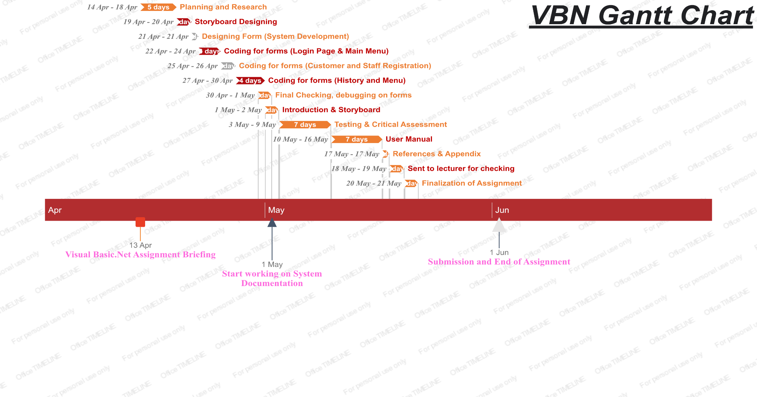



**THANK YOU**

**FOR READING ~ !!!**